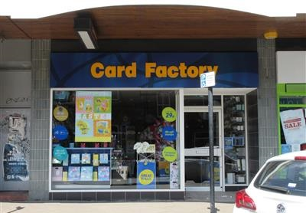

RETAIL UNIT
TO LET

226 FULWOOD ROAD, SHEFFIELD
S10 3BB

LOCATION

The premises occupy an excellent trading location on the ever popular Fulwood Road, a main
arterial route into the City Centre. Broomhilll is a very popular residential area being close to
Sheffield University and the Royal Hallamshire Hospital.

The subject property is situated immediately adjacent to Barnardo’s and Morrisons Local with
Sainsburys Local, Boots and Costa in the same parade. Subway is directly opposite.

On street parking is available immediately outside the premises with a public car park to the
roof of the parade accessed from the rear.

ACCOMMODATION

The premises are arranged on the ground floor only and provide the following approximate
dimensions and floor areas:

Description
Internal Width | 16’9” | 5.15 m
Shop Depth | 52’9” | 16.12 m
Ground Floor | 811 sq ft | 75.3 sq m
The premises are serviced from the rear at first floor level.

LEASE

The premises are available on a new, effectively full repairing (by way of service charge) and
insuring lease for a term to be agreed, subject to five yearly upward only rent reviews.

RENT

£25,000 (twenty five thousand pounds) per annum exclusive of VAT, Rates and Service Charge.

RATES

Description | Shop and Premises
Rateable Value (2020/21) | £19,250
UBR (2020/21) | 49.9p

Please note interested parties are advised to make their own enquiries with the Local Charging Authorities.

COSTS

The tenant is to be responsible for their own legal costs including Stamp Duty and VAT.

VIEWING

Strictly by appointment through:-

Paul Lancaster Property Consultants
Tom Lancaster
T: 0114 279 2852
M: 07837936710
E: tom@paul-lancaster.co.uk

EPC

Available on request

